**Candidates for Vice President**

**John Burrafato**

I seek your support as candidate for Vice President of the Floyd Bennett Garden Association (FBGA).

I am married and have lived in Brooklyn most of my life. I worked for the Department of Sanitation of New York for 25 years, first as a hands-on sanitation worker and then as a supervisor. I serve my local community of Gerritsen Beach and have also spent 22 years on the board of the Bay Ridge Rod and Gun Club. My grandfather introduced me to gardening at his property in Long Island when I was only 7 years old. He taught me well—how to tend to a garden, respect nature, and give back to the land.

I’ve been a FBGA member since 2013, where I garden seven days a week. I love working on my own garden, and helping others enhance theirs. Before becoming a board member and the chair of The Wildlife Habitat in 2021, I worked on almost every major project at FBGA and worked with other committees, such as Construction, Plumbing, Maintenance/ Operation, Education, the Habitat, and Help a Gardener. As the Habitat Committee Chair, I have led volunteers to maintain the habitat for wildlife, install and secure new benches for gardeners to enjoy as well as performed general maintenance including grass cutting and sprinkling. I have managed and recruited volunteers for work parties where we weed, do general maintenance, plant trees, bushes, flowers and remove dead trees. I carved and painted a new entry sign for Habitat with flower bed.

Why I will be a good VP of FBGA.

I love gardening. I have extensive experience at FBGA. I have worked well with other FBGA committees, chairs, volunteers, and new gardeners over the years. My life/carrier experience and FBGA experience demonstrate that I can do and enjoy hands-on work, but that I can also manage projects and delegate work.

My personal statement is:

“If I see a job that needs to be done, no matter where in the garden–the picnic area, the containers, the Habitat or elsewhere– I help out.”

**Danny Puntorno**

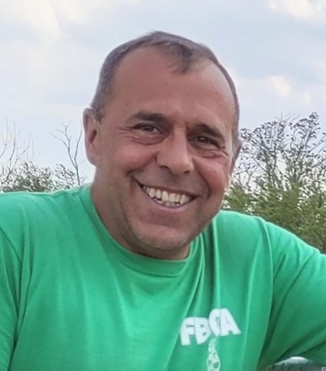My name is Danny Puntorno and I am running for Vice President of FBGA.

I have been a member since 2009 and can't imagine leaving this little oasis we call the garden. I inherited the garden bug from my Father, watching him grow tomatoes and other vegetables in our backyard.

When my name was finally called from the waiting list I began my own gardening adventure, while getting to meet so many great people who share the love of nature and gardening.

Through the years, I have taken many responsibilities here at FBGA, currently serving as Chairperson of the construction committee. I also serve as VP of my Union, ensuring that all members are served by the administration.

With your support I hope to prove myself an effective member of the FBGA team, and keep the garden the beautiful place we know.

**Candidate for Recording Secretary**

**Anne Gaudet​**

FBGA has been an important part of my life for ~ 27 years. It is my “happy place", and my summer family.

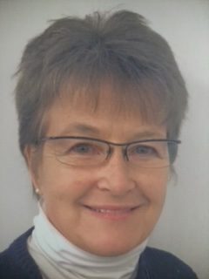

I’m running for the position of Recording Secretary. This position is important as the Secretary records the Minutes of all FBGA Board Meetings, and maintains them for future reference. They should follow Robert’s Rules of Order, be concise, and document all actions taken by the Board.

Though I did not win the position when I last ran two years ago, I have written most of the FBGA Board Minutes at the Board’s request this past term. Nominated again this year, I am running to officially have the position. That decision is up to you, my fellow garden members.

From college onward I’ve served in different capacities on different Boards, in both elected and appointed positions. Presently I serve FBGA on the Board as the Education Committee Chair (2 years), and continue to serve on civic and professional boards as well.

I’m trained as a Registered Nurse, and presently work in business management. Having worked in different fields encourages me have a broad view of both situations, and solutions.

Over the years we may have met at different FBGA Events, or worked on Community Service projects together? Even though Community Service is required, I view these hours as opportunities to meet members, which fosters a further sense of community. Our membership rolls continue to change of course, and we are blessed to have members that represent the NYC of today, which is a great thing! We’re comprised of a great group of people!

I hope you to agree that I can serve FBGA well as the next Recording Secretary, and I hope you choose to vote for me. I will do a good job for you going forward!

Respectfully submitted, with many thanks, Anne Gaudet J36U

**Lynn Halligan**

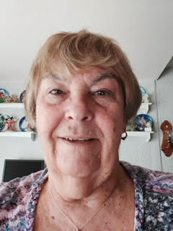I have been a member of the FBGA community gardens for more than 22 years. I have been a member of the Board of Directors for over 17 years. I was Chair of Special Events until I was elected as Recording Secretary in 2009.

My responsibilities were performed to the best of my ability. Whenever needed, I have assisted our administrators above and beyond the duties specified in our Bylaws, including assisting with annual membership renewals.

If re-elected, I will continue to perform whatever duties necessary to help our organization run as smoothly, fairly and effectively as possible,   
for all members, to the best of my ability.